CI/CD DevOps

Introduction to CI/CD

What is CI/CD?
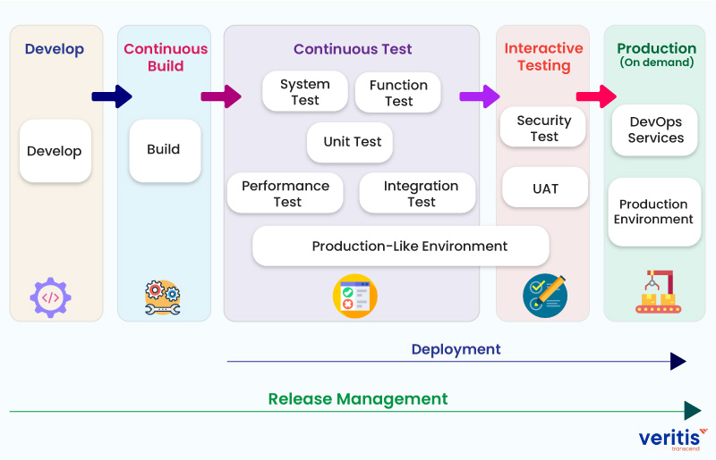
CI (Continuous Integration) is a development practice where developers frequently integrate code changes into a shared repository. Each integration triggers automated builds and tests.
CD (Continuous Deployment/Delivery) extends CI by automatically deploying code changes to production or staging environments after passing all tests.

Key Benefits
- ✅ Faster Release Cycles: Automate repetitive tasks
- ✅ Early Bug Detection: Catch issues before production
- ✅ Improved Code Quality: Automated testing and code analysis
- ✅ Reduced Manual Errors: Eliminate human mistakes in deployment
- ✅ Better Collaboration: Teams can work in parallel with confidence

CI/CD Concepts

Continuous Integration (CI)
Developer → Commit Code → Automated Build → Run Tests → Report Results
Process:
- Developer commits code to version control
- CI server detects the change
- Automatically builds the application
- Runs automated tests (unit, integration)
- Generates reports and notifications

Continuous Delivery (CD)
CI Pipeline → Automated Tests → Staging Deployment → Manual Approval → Production
Process:
- Code passes all CI checks
- Automatically deploys to staging environment
- Manual approval gate
- Deploy to production

Continuous Deployment
CI Pipeline → Automated Tests → Auto-Deploy to Production
Difference: No manual approval - fully automated deployment to production.

CI/CD Pipeline Architecture
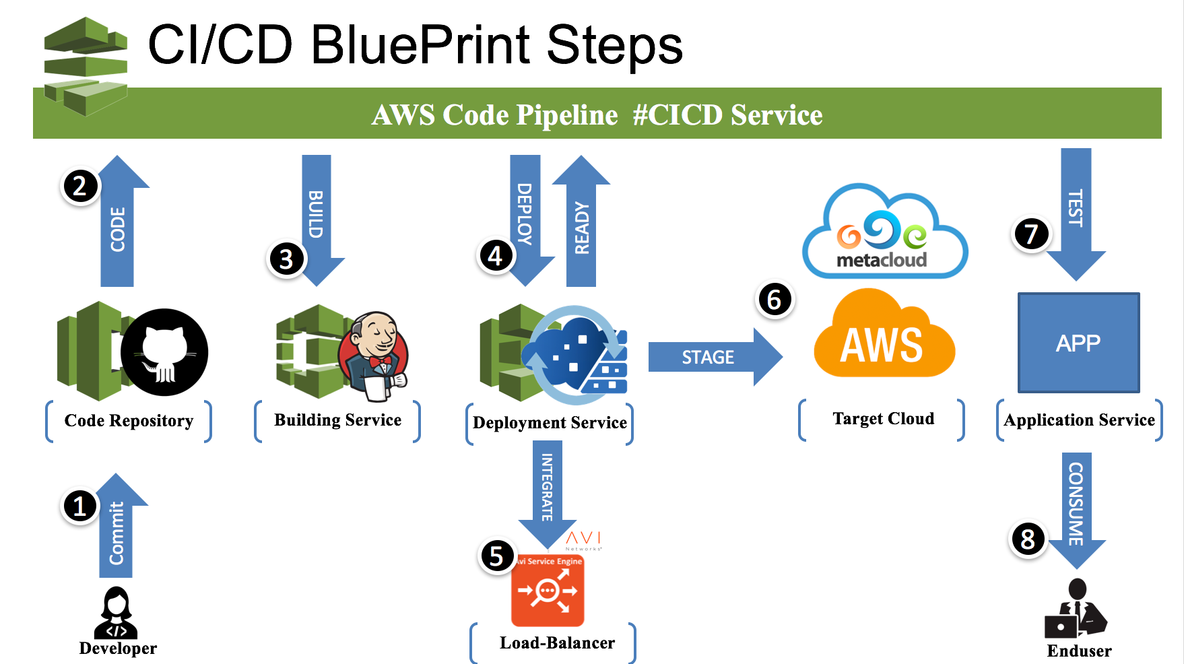

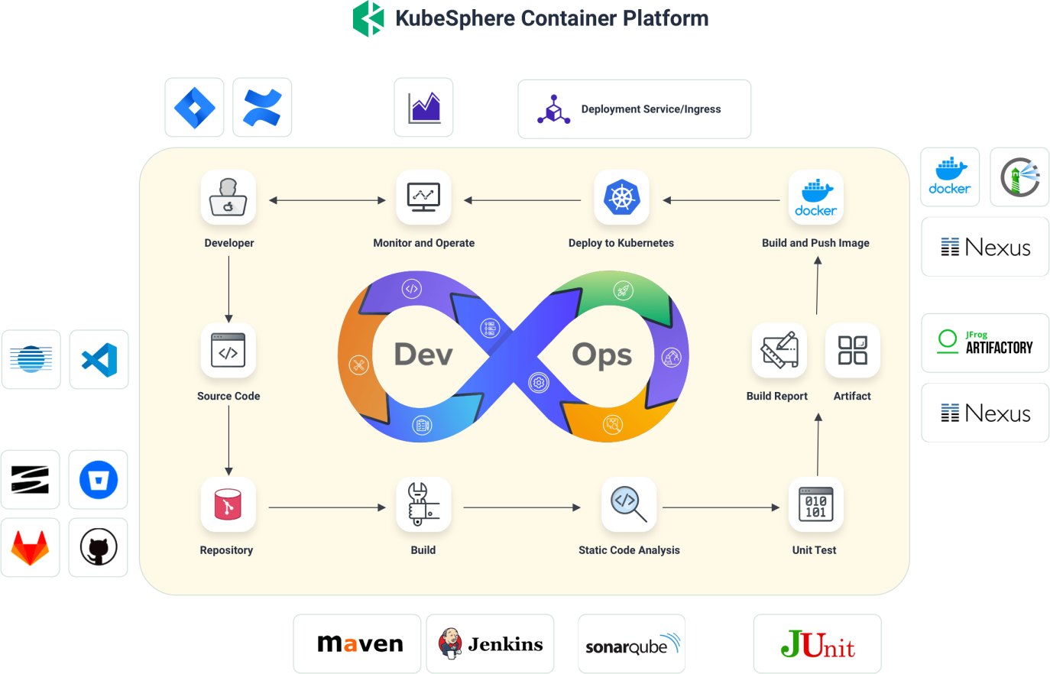

Detailed Pipeline Stages
┌─────────────────────────────────────────────────────────────┐
│ CI/CD PIPELINE │
├─────────────────────────────────────────────────────────────┤
│ │
│ [Source] → [Build] → [Test] → [Package] → [Deploy] │
│ │ │ │ │ │ │
│ │ │ │ │ │ │
│ ▼ ▼ ▼ ▼ ▼ │
│ Git Compile Unit Docker Kubernetes │
│ Repo Code Tests Image Cluster │
│ │
└─────────────────────────────────────────────────────────────┘

Pipeline Stages Explained
- Source Stage
  - Trigger: Code commit, PR, or scheduled
  - Actions: Checkout code, validate changes
- Build Stage
  - Compile source code
  - Install dependencies
  - Create artifacts
- Test Stage
  - Unit tests
  - Integration tests
  - Code coverage
  - Security scanning
- Package Stage
  - Create Docker images
  - Build deployment packages
  - Version artifacts
- Deploy Stage
  - Deploy to staging
  - Run smoke tests
  - Deploy to production (with approval)
- Monitor Stage
  - Health checks
  - Performance monitoring
  - Log aggregation

Open Source CI/CD Tools

GitHub Actions
Overview: Integrated CI/CD solution within GitHub repositories.
Key Features:
- ✅ Native GitHub integration
- ✅ Free for public repositories
- ✅ YAML-based configuration
- ✅ Large marketplace of actions
- ✅ Supports matrix builds
- ✅ Self-hosted runners available
Example Workflow:
name: CI/CD Pipeline

on:
push:
branches: [ main, develop ]
pull_request:
branches: [ main ]

jobs:
build:
runs-on: ubuntu-latest

steps:
- uses: actions/checkout@v3

- name: Set up Node.js
uses: actions/setup-node@v3
with:
node-version: '18'

- name: Install dependencies
run: npm install

- name: Run tests
run: npm test

- name: Build application
run: npm run build

- name: Build Docker image
run: docker build -t myapp:${{ github.sha }} .

- name: Push to registry
run: |
echo ${{ secrets.DOCKER_PASSWORD }} | docker login -u ${{ secrets.DOCKER_USERNAME }} --password-stdin
docker push myapp:${{ github.sha }}
Pricing:
- Free: 2,000 minutes/month for private repos
- Team: $4/user/month
- Enterprise: Custom pricing

GitLab CI/CD
Overview: Built-in CI/CD platform in GitLab.
Key Features:
- ✅ Integrated with GitLab
- ✅ Free for public projects
- ✅ Docker-in-Docker support
- ✅ Auto DevOps pipelines
- ✅ Built-in container registry
- ✅ Kubernetes integration
Example .gitlab-ci.yml:
stages:
- build
- test
- deploy

variables:
DOCKER_DRIVER: overlay2
DOCKER_TLS_CERTDIR: "/certs"

build:
stage: build
image: docker:latest
services:
- docker:dind
script:
- docker build -t $CI_REGISTRY_IMAGE:$CI_COMMIT_SHA .
- docker login -u $CI_REGISTRY_USER -p $CI_REGISTRY_PASSWORD $CI_REGISTRY
- docker push $CI_REGISTRY_IMAGE:$CI_COMMIT_SHA

test:
stage: test
image: node:18
script:
- npm install
- npm test
- npm run lint

deploy:
stage: deploy
image: alpine:latest
script:
- apk add --no-cache curl
- curl -X POST $DEPLOY_WEBHOOK
only:
- main
Pricing:
- Free: Unlimited CI/CD minutes for public projects
- Premium: $29/user/month
- Ultimate: $99/user/month

Jenkins
Overview: Open-source automation server.
Key Features:
- ✅ Highly customizable
- ✅ Extensive plugin ecosystem
- ✅ Self-hosted
- ✅ Supports pipelines as code (Jenkinsfile)
- ✅ Free and open-source
Example Jenkinsfile (Declarative Pipeline):
pipeline {
agent any

environment {
DOCKER_REGISTRY = 'myregistry.com'
IMAGE_NAME = 'myapp'
}

stages {
stage('Checkout') {
steps {
checkout scm
}
}

stage('Build') {
steps {
sh 'npm install'
sh 'npm run build'
}
}

stage('Test') {
steps {
sh 'npm test'
}
}

stage('Docker Build') {
steps {
sh "docker build -t ${IMAGE_NAME}:${BUILD_NUMBER} ."
}
}

stage('Deploy') {
when {
branch 'main'
}
steps {
sh "docker push ${IMAGE_NAME}:${BUILD_NUMBER}"
sh "kubectl set image deployment/myapp app=${IMAGE_NAME}:${BUILD_NUMBER}"
}
}
}

post {
success {
echo 'Pipeline succeeded!'
}
failure {
echo 'Pipeline failed!'
}
}
}
Pricing:
- Free (open-source)

Other Open Source Tools
- CircleCI: Cloud-based CI/CD
- Travis CI: Hosted CI service
- Drone: Container-native CI/CD
- Tekton: Kubernetes-native CI/CD
- ArgoCD: GitOps continuous delivery

AWS CI/CD Services

AWS CodeCommit
Overview: Fully managed source control service.
Key Features:
- ✅ Private Git repositories
- ✅ Integrated with other AWS services
- ✅ Encrypted at rest and in transit
- ✅ Branch-level permissions
- ✅ Pull request workflows
Pricing:
- First 5 users: Free
- Additional users: $1/user/month
- Storage: $0.06/GB/month
- Requests: $0.001 per request
Example Setup:
# Configure Git credentials
git config --global credential.helper '!aws codecommit credential-helper $@'
git config --global credential.UseHttpPath true

# Clone repository
git clone https://git-codecommit.us-east-1.amazonaws.com/v1/repos/my-repo

AWS CodeBuild
Overview: Fully managed build service.
Key Features:
- ✅ Pay-per-use pricing
- ✅ Supports multiple languages
- ✅ Docker support
- ✅ Custom build environments
- ✅ Integration with CodeCommit, GitHub, Bitbucket
Example buildspec.yml:
version: 0.2

phases:
pre_build:
commands:
- echo Logging in to Amazon ECR...
- aws ecr get-login-password --region $AWS_DEFAULT_REGION | docker login --username AWS --password-stdin $AWS_ACCOUNT_ID.dkr.ecr.$AWS_DEFAULT_REGION.amazonaws.com
- COMMIT_HASH=$(echo $CODEBUILD_RESOLVED_SOURCE_VERSION | cut -c 1-7)
- IMAGE_TAG=${COMMIT_HASH:=latest}
build:
commands:
- echo Build started on `date`
- echo Building the Docker image...
- docker build -t $IMAGE_REPO_NAME:$IMAGE_TAG .
- docker tag $IMAGE_REPO_NAME:$IMAGE_TAG $AWS_ACCOUNT_ID.dkr.ecr.$AWS_DEFAULT_REGION.amazonaws.com/$IMAGE_REPO_NAME:$IMAGE_TAG
post_build:
commands:
- echo Build completed on `date`
- echo Pushing the Docker image...
- docker push $AWS_ACCOUNT_ID.dkr.ecr.$AWS_DEFAULT_REGION.amazonaws.com/$IMAGE_REPO_NAME:$IMAGE_TAG
- echo Writing image definitions file...
- printf '[{"name":"myapp","imageUri":"%s"}]' $AWS_ACCOUNT_ID.dkr.ecr.$AWS_DEFAULT_REGION.amazonaws.com/$IMAGE_REPO_NAME:$IMAGE_TAG > imagedefinitions.json
artifacts:
files:
- imagedefinitions.json
Pricing:
- Compute: $0.005 per build minute (Linux)
- Storage: $0.03/GB/month

AWS CodeDeploy
Overview: Automated deployment service.
Key Features:
- ✅ Multiple deployment strategies
- ✅ Rollback capabilities
- ✅ Health checks
- ✅ Supports EC2, Lambda, ECS, on-premises
Deployment Strategies:
- All at Once: Deploy to all instances simultaneously
- Rolling: Deploy to instances in batches
- Blue/Green: Deploy to new environment, then switch traffic
Example appspec.yml (EC2/On-Premises):
version: 0.0
os: linux
files:
- source: /
destination: /var/www/html
hooks:
BeforeInstall:
- location: scripts/install_dependencies.sh
timeout: 300
runas: root
AfterInstall:
- location: scripts/configure_app.sh
timeout: 300
runas: root
ApplicationStart:
- location: scripts/start_server.sh
timeout: 300
runas: root
ApplicationStop:
- location: scripts/stop_server.sh
timeout: 300
runas: root
Example appspec.yml (ECS):
version: 0.0
Resources:
- TargetService:
Type: AWS::ECS::Service
Properties:
TaskDefinition: "<TASK_DEFINITION>"
LoadBalancerInfo:
ContainerName: "web"
ContainerPort: 80
Pricing:
- Free (no additional charges)

AWS CodePipeline
Overview: Fully managed continuous delivery service.
Key Features:
- ✅ Visual pipeline editor
- ✅ Integrates with AWS services
- ✅ Manual approval gates
- ✅ Parallel executions
Example Pipeline Structure:
{
"pipeline": {
"name": "MyAppPipeline",
"roleArn": "arn:aws:iam::account:role/CodePipelineRole",
"stages": [
{
"name": "Source",
"actions": [
{
"name": "SourceAction",
"actionTypeId": {
"category": "Source",
"owner": "AWS",
"provider": "CodeCommit",
"version": "1"
},
"configuration": {
"RepositoryName": "my-repo",
"BranchName": "main"
}
}
]
},
{
"name": "Build",
"actions": [
{
"name": "BuildAction",
"actionTypeId": {
"category": "Build",
"owner": "AWS",
"provider": "CodeBuild",
"version": "1"
},
"configuration": {
"ProjectName": "my-build-project"
}
}
]
},
{
"name": "Deploy",
"actions": [
{
"name": "DeployAction",
"actionTypeId": {
"category": "Deploy",
"owner": "AWS",
"provider": "CodeDeploy",
"version": "1"
},
"configuration": {
"ApplicationName": "my-app",
"DeploymentGroupName": "production"
}
}
]
}
]
}
}
Pricing:
- First pipeline: Free (1 active pipeline/month)
- Additional pipelines: $1/month per active pipeline

Tool Comparisons

Version Control: GitHub vs GitLab vs AWS CodeCommit
Feature | GitHub | GitLab | AWS CodeCommit
Hosting | Cloud/Self-hosted | Cloud/Self-hosted | Cloud only
Free Tier | Unlimited public repos | Unlimited public/private | 5 users free
CI/CD | GitHub Actions | Built-in CI/CD | Requires CodePipeline
Issue Tracking | ✅ Yes | ✅ Yes | ❌ No
Wiki | ✅ Yes | ✅ Yes | ❌ No
Container Registry | ✅ GitHub Container Registry | ✅ Built-in | ❌ No (use ECR)
AWS Integration | ⚠️ Limited | ⚠️ Limited | ✅ Native
Pricing | $0-21/user/month | $0-99/user/month | $1/user/month
Best For | Open source, general use | DevOps teams, self-hosting | AWS-native projects
When to Use Each:
- GitHub: Open source projects, large community, extensive marketplace
- GitLab: All-in-one DevOps platform, self-hosting options, built-in CI/CD
- CodeCommit: AWS-native projects, tight AWS integration, compliance requirements

CI/CD: GitHub Actions vs GitLab CI vs AWS CodeBuild/CodePipeline
Feature | GitHub Actions | GitLab CI | AWS CodeBuild/Pipeline
Setup Complexity | ⭐ Easy | ⭐⭐ Medium | ⭐⭐⭐ Complex
Configuration | YAML in repo | YAML in repo | JSON/YAML separate
Free Tier | 2,000 min/month | Unlimited (public) | 1 pipeline free
Self-Hosted Runners | ✅ Yes | ✅ Yes | ❌ No
AWS Integration | ⚠️ Via actions | ⚠️ Via integrations | ✅ Native
Multi-Cloud | ✅ Yes | ✅ Yes | ❌ AWS only
Cost Model | Per-minute | Per-minute/user | Per-build/pipeline
Best For | GitHub repos | GitLab repos | AWS-native stacks
Cost Comparison Example (100 builds/month):
- GitHub Actions: ~$0-15/month (if within free tier)
- GitLab CI: Free (public) or $29/user/month
- AWS CodeBuild: ~$5-20/month (depending on build time)
- AWS CodePipeline: $1/month (first pipeline free)

Deployment: AWS CodeDeploy vs Alternatives
Feature | AWS CodeDeploy | GitLab Auto Deploy | GitHub Actions Deploy
Deployment Strategies | ✅ Multiple | ⚠️ Limited | ⚠️ Manual setup
Rollback | ✅ Automatic | ✅ Yes | ⚠️ Manual
Health Checks | ✅ Built-in | ⚠️ Custom | ⚠️ Custom
AWS Integration | ✅ Native | ⚠️ Via API | ⚠️ Via API
Cost | Free | Included | Free (compute only)

Practical Examples

Example 1: Simple Node.js Application
GitHub Actions Workflow:
name: Node.js CI/CD

on:
push:
branches: [ main ]
pull_request:
branches: [ main ]

jobs:
test:
runs-on: ubuntu-latest
steps:
- uses: actions/checkout@v3
- uses: actions/setup-node@v3
with:
node-version: '18'
- run: npm ci
- run: npm test
- run: npm run lint

build:
needs: test
runs-on: ubuntu-latest
steps:
- uses: actions/checkout@v3
- uses: actions/setup-node@v3
with:
node-version: '18'
- run: npm ci
- run: npm run build
- uses: actions/upload-artifact@v3
with:
name: dist
path: dist/

deploy:
needs: build
runs-on: ubuntu-latest
if: github.ref == 'refs/heads/main'
steps:
- uses: actions/download-artifact@v3
with:
name: dist
- name: Deploy to production
run: |
# Your deployment script here
echo "Deploying to production..."

Example 2: Docker Application with AWS
AWS CodePipeline with CodeBuild:
# buildspec.yml
version: 0.2

phases:
pre_build:
commands:
- echo Logging in to Amazon ECR...
- aws ecr get-login-password --region $AWS_DEFAULT_REGION | docker login --username AWS --password-stdin $AWS_ACCOUNT_ID.dkr.ecr.$AWS_DEFAULT_REGION.amazonaws.com
- REPOSITORY_URI=$AWS_ACCOUNT_ID.dkr.ecr.$AWS_DEFAULT_REGION.amazonaws.com/$IMAGE_REPO_NAME
- COMMIT_HASH=$(echo $CODEBUILD_RESOLVED_SOURCE_VERSION | cut -c 1-7)
- IMAGE_TAG=${COMMIT_HASH:=latest}
build:
commands:
- echo Build started on `date`
- echo Building the Docker image...
- docker build -t $IMAGE_REPO_NAME:$IMAGE_TAG .
- docker tag $IMAGE_REPO_NAME:$IMAGE_TAG $REPOSITORY_URI:$IMAGE_TAG
- docker tag $IMAGE_REPO_NAME:$IMAGE_TAG $REPOSITORY_URI:latest
post_build:
commands:
- echo Build completed on `date`
- echo Pushing the Docker images...
- docker push $REPOSITORY_URI:$IMAGE_TAG
- docker push $REPOSITORY_URI:latest
- echo Writing image definitions file...
- printf '[{"name":"app","imageUri":"%s"}]' $REPOSITORY_URI:$IMAGE_TAG > imagedefinitions.json
artifacts:
files:
- imagedefinitions.json

Interview Questions

Beginner Questions
- What is CI/CD?
  - Answer: CI (Continuous Integration) is the practice of frequently integrating code changes with automated builds and tests. CD (Continuous Deployment/Delivery) extends this by automatically deploying code that passes all tests.
- What's the difference between Continuous Delivery and Continuous Deployment?
  - Answer: Continuous Delivery requires manual approval before production deployment, while Continuous Deployment automatically deploys to production after passing all checks.
- What are the main stages of a CI/CD pipeline?
  - Answer: Source (code checkout), Build (compile/package), Test (unit/integration tests), Package (create artifacts), Deploy (deploy to environments), Monitor (health checks).
- What is a build artifact?
  - Answer: A build artifact is a file or set of files produced during the build process, such as compiled binaries, Docker images, or deployment packages.
- What is GitOps?
  - Answer: GitOps is a methodology where Git is the single source of truth for declarative infrastructure and applications. Changes are made through Git commits, and automated processes apply those changes.

Intermediate Questions
- How would you implement a blue/green deployment?
  - Answer: Maintain two identical production environments (blue and green). Deploy new version to inactive environment, run tests, then switch traffic. Keep old environment for quick rollback.
- What is the difference between GitHub Actions and GitLab CI?
  - Answer: GitHub Actions is GitHub's CI/CD solution with marketplace integrations. GitLab CI is built into GitLab with more comprehensive DevOps features. Both use YAML configuration.
- How do you handle secrets in CI/CD pipelines?
  - Answer: Use secret management services (AWS Secrets Manager, GitHub Secrets, HashiCorp Vault). Never hardcode secrets. Use environment variables or secret injection at runtime.
- What is a build matrix?
  - Answer: A build matrix runs the same job across multiple configurations (e.g., different Node.js versions, operating systems) in parallel to ensure compatibility.
- How would you optimize a slow CI/CD pipeline?
  - Answer: Parallelize jobs, cache dependencies, use faster runners, split large test suites, optimize Docker builds with multi-stage builds, use build artifacts efficiently.

Advanced Questions
- Compare AWS CodePipeline with GitHub Actions for an AWS-native application.
  - Answer: CodePipeline offers native AWS integration, better IAM integration, and AWS service-specific features. GitHub Actions is more flexible, has better community support, and works across clouds. Choose CodePipeline for AWS-only, GitHub Actions for multi-cloud or GitHub-hosted code.
- How would you implement canary deployments?
  - Answer: Deploy new version to a small percentage of traffic, monitor metrics (error rates, latency), gradually increase traffic if healthy, rollback if issues detected. Use tools like AWS CodeDeploy, Spinnaker, or Istio.
- What is infrastructure as code (IaC) and how does it relate to CI/CD?
  - Answer: IaC manages infrastructure through code (Terraform, CloudFormation). In CI/CD, infrastructure changes are versioned, tested, and deployed through the same pipeline as application code.
- How do you handle database migrations in a CI/CD pipeline?
  - Answer: Version migrations, run them as part of deployment pipeline, test on staging first, use backward-compatible changes, have rollback scripts ready, consider blue/green for zero-downtime.
- What are the security considerations for CI/CD pipelines?
  - Answer: Secure secret storage, least privilege access, scan dependencies and images, sign artifacts, audit logs, network isolation, regular credential rotation, vulnerability scanning.

Scenario-Based Questions
- Your pipeline is failing intermittently. How do you debug it?
  - Answer: Check logs, look for race conditions, verify test isolation, check resource limits, review recent changes, add more logging, use retry mechanisms for flaky tests.
- How would you set up CI/CD for a monorepo with multiple services?
  - Answer: Use path-based triggers, build only changed services, share common dependencies, use workspace caching, implement service-specific pipelines, coordinate deployments.
- Your deployment takes 30 minutes. How do you reduce it?
  - Answer: Optimize Docker builds (multi-stage, layer caching), parallelize steps, use faster infrastructure, reduce test execution time, deploy only changed components, use blue/green to eliminate downtime.
- How do you ensure zero-downtime deployments?
  - Answer: Use blue/green or canary deployments, health checks, graceful shutdowns, load balancer configuration, database migration strategies, feature flags for gradual rollout.
- How would you implement CI/CD for a microservices architecture?
  - Answer: Service-specific pipelines, independent deployments, API contract testing, service mesh for traffic management, centralized logging/monitoring, versioned APIs, container orchestration.

Tool-Specific Questions
- When would you choose AWS CodeCommit over GitHub?
  - Answer: When you need tight AWS integration, compliance requirements for data residency, existing AWS infrastructure, or want unified AWS billing.
- What are the advantages of GitLab CI over Jenkins?
  - Answer: Built-in Git integration, modern YAML-based config, integrated container registry, better UI, GitOps support, less maintenance overhead.
- How does AWS CodeDeploy handle rollbacks?
  - Answer: Automatic rollback on health check failures, manual rollback through console/CLI, maintains previous deployment revision, can rollback to any previous version.
- What is the difference between GitHub Actions self-hosted runners and GitHub-hosted runners?
  - Answer: Self-hosted runners run on your infrastructure, offer more control, custom configurations, and can be more cost-effective for high usage. GitHub-hosted are managed, always up-to-date, but have usage limits.
- How do you integrate AWS CodePipeline with GitHub?
  - Answer: Use GitHub as source action in CodePipeline, configure OAuth connection, CodePipeline polls GitHub for changes, triggers pipeline on commits/PRs.

